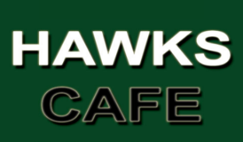
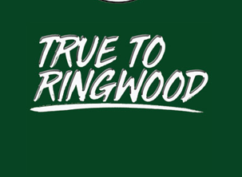
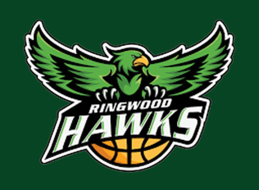

School Holiday Lunch Order Form
Name: | Group:  BLUE GREEN RED BLACK
Day Attending: | Food Allergies:
Tick the Meal Deal Box Below and tick which drink you would like:
HOT DOG Meal Deal - $7.00  HOT DOG, DRINK, ZOOPER DOOPER  (Don’s Frankfurt & Bakers Delight Roll) | 600ml Water  Apple Pop Top  Apple & Blackcurrant Pop Top  Orange Pop Top
CHICKEN NUGGEST & CHIPS  Meal Deal - $9.00  3 x Chicken Nuggets & Chips  DRINK  ZOOPER DOOPER | 600ml Water  Apple Pop Top  Apple & Blackcurrant Pop Top  Orange Pop Top
Additional items below. Write the quantity and total:
DRINKS | PRICE | QUANTITY | TOTAL
600ml Water | $3.50
Gatorade No Sugar – Orange, Lemon, Berry, Glacier Ice, Grape | $5.00
Gatorade – Blue Bolt, Lemon Lime, Green Apple, Tropical, Orange, Grape, Watermelon, | $5.00
600ml Soft Drink – Pepsi Max, Pepsi, No Sugar Solo, No Sugar Lemonade, Raspberry | $5.00
Juice – Apple, Orange | $5.00
Pop Top – Apple, Apple & Blackcurrant, Orange | $2.50
HOT FOOD
Hot Dog (Don’s Frankfurt & Bakers Delight Roll) | $4.00
Regular Hot Chips | $4.50
Dim Sims (Fried or Steamed) | $1.50
Potato Cakes | $1.50
Chicken Nuggets (3 for $2) | $2.50
SNACKS
Sour Worms, Sour Straps, Zappos, Fizzers, Chuppa Chup, | $1.00
Lolly Cups, Ring Pops, Melody Pops | $2.00
Mini M&M’s, Mentos | $2.50
Chocolate Bars / Lollies – Dairy Milk, Kit Kat, Mars, Mini M&M’s, Boost, Mentos, Mega Snake | $3.00
TOTAL (Include Meal Deal Amount if you have selected one) | $

